EAST COTTINGWITH
Parish Council

Emergency Procedures
Emergencies like road accidents, fires and medical emergencies happen somewhere in the country almost every minute of every day and are dealt with quickly and efficiently by the emergency services.

East Riding of Yorkshire Council (ERYC) and other responding organisations have emergency plans in place for larger events that stretch the resources of the emergency services and affect large numbers of people or the environment.

How Town & Parish Councils will be notified of an Emergency

Town and Parish Councils will always be notified about a declared emergency that they will be affected by. The type of notification will depend on the type of emergency and is outlined below. Elected Members will also be notified in the same way.

- In the event of a localised emergency that impacts on one or a small number of towns or parishes, the clerk will usually be telephoned by the Head of Service who is co-ordinating the Council’s response to the emergency. The Head of Service will be known as a Control Centre Manager when they are in this co-ordination role.

- In the event of a wide area emergency that impacts on many wards across the East Riding of Yorkshire, initial notification is likely to come from an email sent from ‘alertparish’, the Emergency Planning team or from the Emergency Control Centre.

- If you have signed up for our text alert service you may also be sent an SMS with information. Texts will begin with EmgncyAlert, you will not be able to respond directly to these notifications but if you have any questions please contact the Customer Service Centre.

There is often an information vacuum at the start of an emergency, with responding organisations trying to ascertain exactly what has happened and what the consequences are. However, the notification will take place as soon as possible after arrangements have been put into place to implement the Council’s response to an emergency.

Communicating with Town and Parish Councils during an Emergency

The Town and Parish Council emergency hotline will usually be the primary point of contact for you during an emergency. Information about the emergency response will be cascaded by the Emergency Control Centre, and the switchboard will be able to direct any queries or issues towards the appropriate Council teams. It is likely that to take some time to respond to enquiries during the initial stages of an emergency.

The Council’s website will also be fully updated with information during an emergency.

Emergency Management Team

In the event of the Emergency plan being triggered the following Parish Councillors and members of the community have agreed to form the Emergency Management Team

(Please note the on-line version of this plan has had all contact details removed in line with the Data protection Policy.. Contact details are in the hard copy held in the Phone Box / Book Exchange which is the plan which should be used in the event of an emergency occurring.)

Name | Contact Information | Home address | E-mail address
David Cornmell  Clerk | Home –  Work –  Mobile –
Peter Rhodes  Chair | Home -  Work –  Mobile -
Neil Hobbs  Deputy Chair | Home Work –  Mobile -
Paul Lemkes

Usual Meeting Place

The Emergency Management Team will usually need to meet during an emergency and agree what is to be done. The following meeting locations have been identified:

Address | Keyholder(s) | Keyholder Contacts Details
Village Hall | Paul Lemkes (Chairman) | Home –  Mobile
Village Hall | Sally Hobbs

Public Information

The Parish Council will provide regular updates to the public during an emergency, including passing on messages received by other organisations. The following information channels can be used.

Information Source | Who can access / update? | Contact Details
Parish Council Website  www.eastcottingwith.org.uk | Steve Ashton | 01759 318824
Parish Council Facebook Page  East Cottingwith Village | Open site for general access
Parish Council Noticeboards:  Notice Board  1) Bus stop, Main Street | Neil Hobbs

Emergency Equipment

A Community Public Access Defibrillator is installed at the bus shelter.

Access to the defibrillator is usually given by the 999 operator following a 999 call, rather than being mobilised by the Community Emergency Team.

Emergency contact details - External

East Riding of Yorkshire Council – 01482 393939

- Town & Parish Council Emergency Hotline - 01482 393536.
Email heps@eastriding.org.uk (only monitored during an emergency)
- Highways Customer Care Line - 0845 6001666

Useful Contact Details:

Fire Service, Police, Ambulance & Coastguard | 999
Electricity Emergency Service & Supply Failure | 105
Environment Agency Floodline | 03459 88 11 88
Fire Service – non emergency | 01482 565333
Gas Emergency Service & Gas Escapes | 0800 111 999
NHS – non emergency | 111
Police – non emergency | 101
Yorkshire Water | 08451 24 24 24

Parish Councillors not on Emergency Management Team

Name | Contact Information | Home address | E-mail address
Steve Ashton
Clare Cornmell
David Griffiths
Carol Stevens

ERYC Ward Members

Name | Telephone number | E-mail address
Andrew Burton
David Rudd
Dee Sharpe

MAP OF PARISH

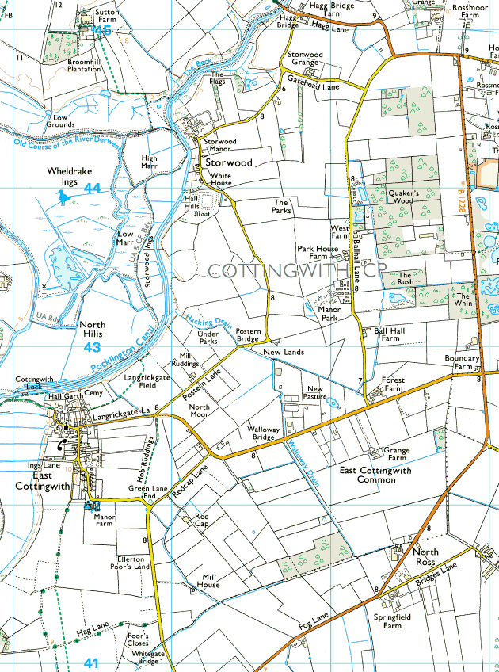
PLAN PUBLICATION AND INFORMATION

Plan Publication

Plan Publication

Electronic copies of this plan have been e-mailed to:

- <heps@eastriding.gov.uk>

The original electronic version of this plan is kept by:
Councillor Steve Ashton

Backup electronic versions of this plan are kept by:
- Parish Clerk

Hard copies of this plan are kept at:
- The village Phone Box / Book Exchange

A web version of the plan with the confidential information removed has been posted on http://www.eastcottingwith.org.uk/policiesprocedures.aspx for public information.

Plan Maintenance

The plan should be reviewed every year at the March Parish Council Meetings. During the review every section of the plan should be checked for accuracy (telephone numbers, resource lists etc). The Clerk will have responsibility for reviewing the emergency plan and should report back the Parish/Town Council meeting to confirm that a review has taken place.

Any updates to the plan, or lessons that have been learned from exercises, should be approved by at least two of the Parish Members before the plan is changed.

The Clerk is responsible for providing an updated version of the plan to all those listed in Section 1.

Data Protection

This plan contains personal information. The Parish Council followed its data protection procedures when completing, maintaining and storing this plan.

Data Privacy procedure can be accessed at:

http://www.eastcottingwith.org.uk/policiesprocedures.aspx

